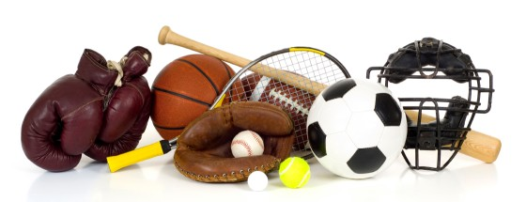
Sports

Due via email to the professor before class on Monday, September 12, 2011

The goal of this assignment is to create a different version of a known sport. Document your process as you go. Your work will be judged on your documentation and how enjoyable a game you manage to create for the intended audience.

- Pick a sport. See below for examples you brainstormed.
- For each category listed below, rate your sport, as compared to all other sports.
  - 1 to means “lowest or smallest compared to other sports.”
  - 10 means “highest or largest compared to other sports.”
- Imagine changing your sport in some way, by significantly changing one of the category ratings. List which category rating you changed.
  - For example, Golf is a 1 on the “Number of players required” scale. Imagine changing that to 10, where you need 100+ players to play a game of Golf.
- Write a description of the new game, and any rules that changed.

Categories
- Minimum number of players required to play
- Size of the play area
- Amount of equipment required to play
- Amount of physical contact during the game
- Length of time the average game takes
- Amount of strength required to play the game well
- Amount of dexterity required to play the game well
- Amount of endurance required to play the game well
- Size of ball required to play (1 = no ball required.)
- Number of balls required to play (1 = no ball required.)

Sports

Archery
Badminton
Baseball
Basketball
Bicycle Racing
Billiards
Boat Racing
Bowling
Boxing
Canoeing
Competitive Cheering
Competitive Dance
Crew
Cricket
Cross country
Curling
Darts
Decathlon
Dodgeball
Drag racing
Fencing
Field Hockey
Figure Skating
Fishing
Football
Go Cart
Golf
Handball
Hockey
Horse riding
Hunting
Jai Lai
Jousting
Karate
Kayaking
Kickball
Lacrosse
Luge
Mixed Martial Arts
Motocross
Nascar
Paintball
Ping Pong
Pole vaulting
Polo
Racquetball
Relay Racing
Rock climbing
Rodeo
Roller blading
Roller hockey
Rugby
Shot put
Skiing
Sky Diving
Snowboarding
Snowshoeing
Soccer
Softball
Squash
Surfing
Swimming
Tae Kwon Do
Tennis
Sprinting
Trap Shooting
Tubing
Turtle Racing
Wakeboarding
Wall Ball
Water Polo
Water Skiing
Weightlifting
Wrestling

Original assignment designed by Professor Ira Fay.

